Module Two essential Question Assignment
Name
Course
Institution
Tutor
Date

Module two essential question assignment
CH.21
Aldosterone
What stimulates its release. Angiotensin II.
Organ that secretes it. Zona glomerulosa of the adrenal cortex in the adrenal gland.
Effects on blood vessels. It causes vasoconstriction.
Antidiuretic Hormone
What stimulates its release. Increase in blood osmolality or decrease in blood volume.
Organ that secretes it. Hypothalamus.
Effect on blood vessels. Vasodilates blood vessels. When it acts on V1 receptors it causes vasoconstriction.
Atrial natriuretic peptide
What stimulates its release. Secreted in response to local heart wall stress
Organ that secretes it. Cardiac Atria.
Effect on blood vessels. It causes vasoconstriction.

Complete this diagram of Capillary Filtration and Reabsorption
- Choose whether there is filtration or reabsorption at the A) arterial end and B) venous end of the capillary. (worth 5 points.)
Answer. Net filtration occurs near the arterial end of the capillary since the hydrostatic pressure for the capillary is greater than the colloidal osmotic pressure for the blood. At the midpoint, there exists no net movement of fluid because the hydrostatic pressure for the capillary equals the blood colloidal pressure. Near the capillary venous end, net reabsorbtion occurs due to higher blood colloidal osmotic pressure than the hydrostatic pressure.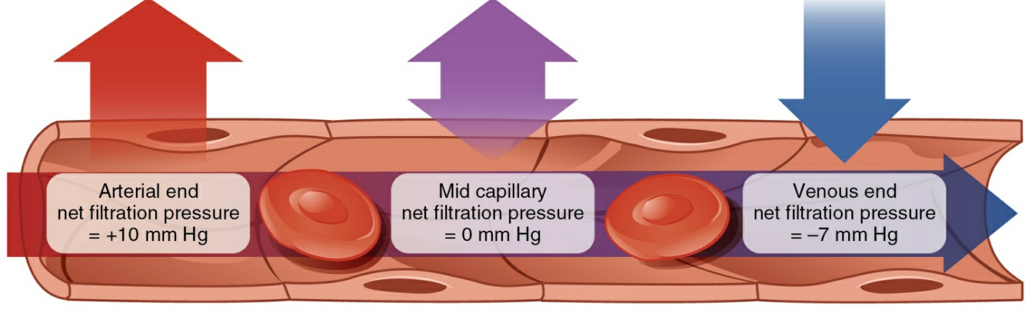
Long description: A capillary with the net filtration pressure at the arterial end (10 mm Hg), middle of the capillary (0 mm Hg), and venous end (-7 mm Hg). There is a red arrow point out of the capillary at the arterial end, a purple arrow point out and into the capillary at the middle portion of the capillary, and a blue arrow pointing into the capillary at the venous end of the capillary. Within the capillary, there is an arrow that points from right to left, it is red at the arterial end, purple in the middle portion, blue at the venous end.

- Using the above diagram as a reference, what four pressures are working in and around the capillary? What direction are they forcing the fluid? (5pts)
Capillary hydrostatic pressure. Pushes the fluid out of the blood vessel into the tissues.
Interstitial fluid hydrostatic pressure.Moves the fluid out of the capillary and into the interstitial fluid
Blood colloidal osmotic pressure. Moves water from the tissue fluid back into the capillary.
Interstial fluid colloidal osmotic pressure. Draws water from the tissue fluid back into the capillary.

- Using the above diagram as a reference, which of the four pressures promote filtration and which of the four promote reabsorption? (5pts)
Answer. Filtration is promoted by blood hydrostatic pressure, interstitial fluid hydrostatic pressureand capillary hydrostatic pressure
Reabsorption promoted by blood colloidal pressure and interstitial fluid colloidal osmotic pressure

Lymphatic System Overview
Correctly fill in the following blanks using the terms provided below. Please keep your Answers HIGHLIGHTED for ease of grading. (Worth 2pts each)

- Helper T Cells
- Plasma cells which produce the specific antibodies for recognition of the humeral pathogen
- Adaptive
- Humeral Immunity
- Nonspecific White Blood Cells
- Cell Mediated Immunity
- Stop pathogens before it enters the body
- Cytoxic T Cells
- Complement Cascade
- Are released from virally infected cells to stimulate neighboring cells to produce antiviral proteins to prevent infection.

- The immune system is divided into 2 parts: Innate (non-specific) and _adaptive_______ (specificity and memory) Immunity .
- There are 2 basic lines of define in innate immunity. The first line of defense consists of physical barriers that are used to stop pathogens before it enters the body________.
  - Give 3 examples of physical barriers below (worth 2pts)
    - ( skin)
    - ( wax and stomach acid
    - (Mucous membrane)
  - The 2nd line of defense uses nonspecific agents to protect the body from invading pathogens.
    - ___Non specific white blood cells____ result in the death of any invading pathogens
      - Give 3 types of these agents (Worth 2pts)
        - (Macrophages in tissues)
        - ( monocytes in blood)
        - ( kuppfer cells in the liver)
  - Chemical mediators give off chemical signals that alert the body of infection. The _complement cascade_______ consists of about 20 proteins that protect the body by destroying pathogens or enhancing other defenses. While Interferons _are released from virally infected cells to stimulate neighbouring cells to produce antiviral proteins to prevent infection______.
- Adaptive Immunity is the 3rd line of defense. In Adaptive Immunity, antigens are processed by an APC and taken to lymphatic tissue to be presented to specific lymphocytes.
  - B cell adaptive immunity is called _____Humeral immunity__. Here B cells are activated and proliferate to produce plasma cells which produce the specific antibodies for recognition of the humeral pathogen______ and memory B Cells which will be available if this specific humeral pathogen returns in the future.
  - T cell adaptive immunity is called _cell mediated immunity______. There are 2 types of T cells. _cytotoxic T cells________ attack specific viruses and pathogens inside a cell. This type of T cell is activated and proliferates. _____Helper T cells_____ aid in the activation of effector B cells and T cells.

Respiratory system chapter 23
Section of pharynx
Narsopharynx
Normally carries air
Made up of which tissue? Epithelial tissue which includes stratified squamous epithelium and pseudostratified columnar epithelium
Why is this tissue best? Contain ciliated cells, goblet cells and basal cells that secrete mucus that traps foreign bodies and microorganisms. Ciliated cells provide mucocilliary escalator that remove small inhaled particles. The lamina propria underlying the basement membrane functions to condition the air thus preventing the epithelium from dehydration from the moving air.
Orapharynx
Normally carries food and/air
Made up of which tissue ? non keratinized squamous stratified epithelium and loose connective tissues and numerous elastic fibers. Also striated skeletal muscles from pharyngeal constrictor
Why is this tissue best. The tissues help guarding from infective agents.
Laryngopharynx
Normally carries both food and air
Made up of which tissue? Ciliated columnar epithelium
Why is this tissue best? Has cilia and mucus that escalate foreign bodies that may have been swallowed.

Use the following data to answer the following questions WORTH 5PTS EACH
  - TIDAL VOLUME= 450ML
  - INSPIRATORY RESERVE VOLUME= 3000ML
  - EXPIRATORY RESERVE VOLUME= 1100ML
  - TOTAL LUNG CAPACITY= 5800 ML

- Is this person’s total lung capacity within the normal range? Yes or No? What is the normal TLC?
Answer YES. The normal total lung capacity is 6000 ML
- Give 2 reasons why someone’s Tidal volume would not be within the 500 mL normal range?
Answer. a. The lung parenchyma may be filled with fluid as in haemothorax reducing the lung recoil decreasing expiration
b.due to obstructive or restrictive respiratory conditionsuch as asthma
- How is the functional residual capacity measured?
Answer. It is the sum inspiratory reserve volume and expiratory reserve volume.
- What are 2 differences between the inspiratory reserve volume and inspiratory capacity.
- Inspiratory reserve volume is the actual amount of air that can be forcefully be inhaled after normal inhalation while Inspiratory capacity is the maximum amount of air that can be inhaled during a forced inhalation.
- Inspiratory capacity is calculated while the inspiratory reserve volume is measured.
- What is the difference between an obstructive vs a restrictive respiratory disorder/disease? Obstructive disease is a condition that results in complete blockage of airways while restrictive disorder results in narrowing of airways in turn resulting to difficult in breathing

